Smoke Test over a QA environment on **16th Dec**

ISF Order capture move order till delivered, full cancellation and partial cancellation with tinted and non-tinted item

Logged in store: **701035** || Account No: **612212472** || Order No: **OM20000000009278 (Non-Tinted Item) - Complete Delivery - PASS**

**Ready for Pickup**

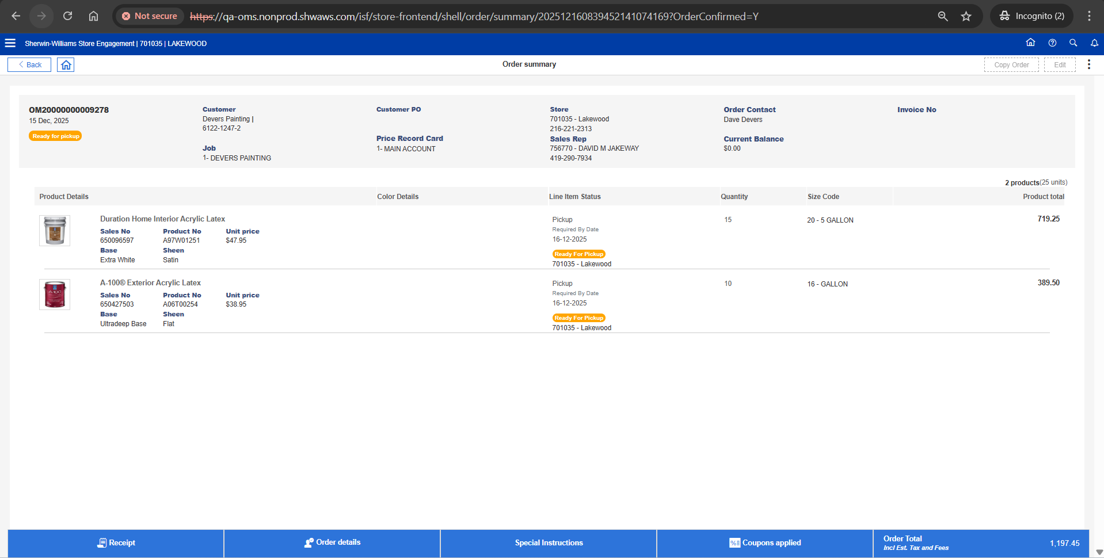

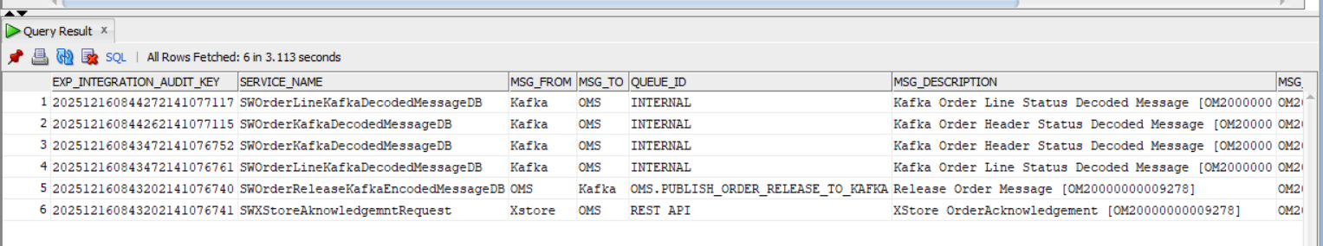

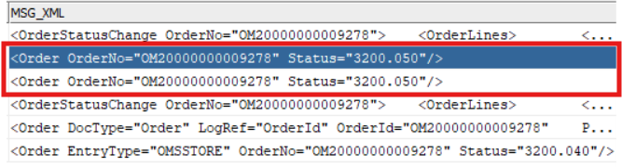

**Customer Picked Up**

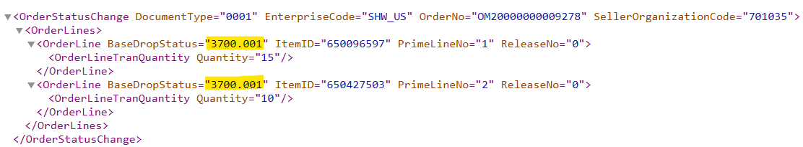

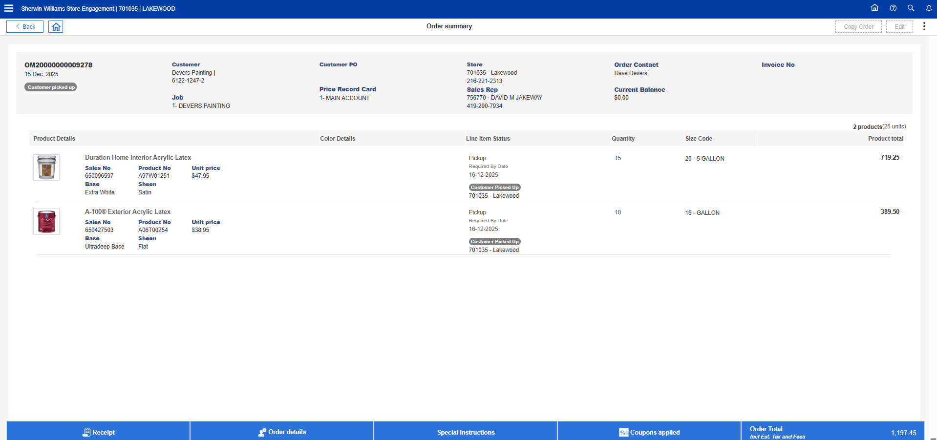

**Release XML**

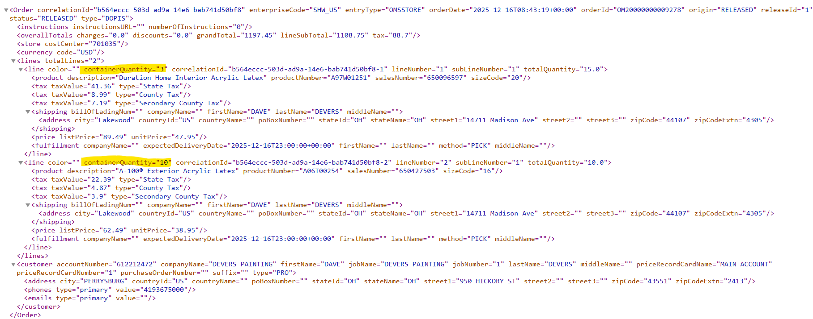

Order No: **OM20000000009286 (Non-Tinted Item) – Full Cancel – PASS**

**Ready for Pick Up**

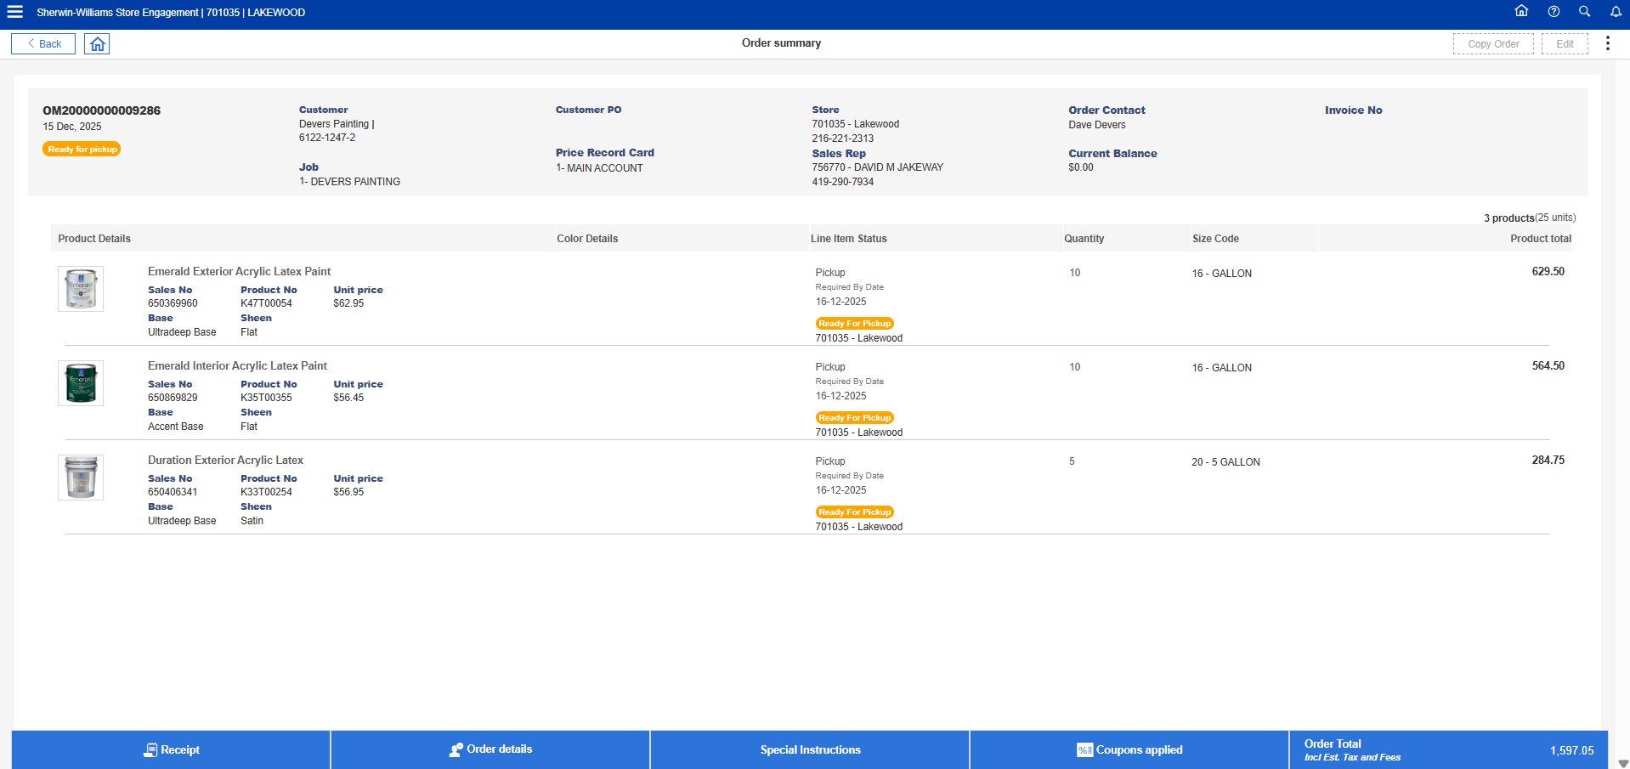

**Full Cancel**

**Release XML**

Logged in Store: **701065** || Account No: **612215780 ||** Order No: **OM20000000009293 (Non-Tinted Item) – Partial line Cancel – PASS**

**Ready for Pick UP**

**Partial line Cancel**

**Release XML**

Order No: **OM20000000009317 (Non-Tinted Item with Customer PO & Notes) – Partial Qty Cancel – PASS**

**Ready for Pickup**

**Partial Qty Cancel in both lines**

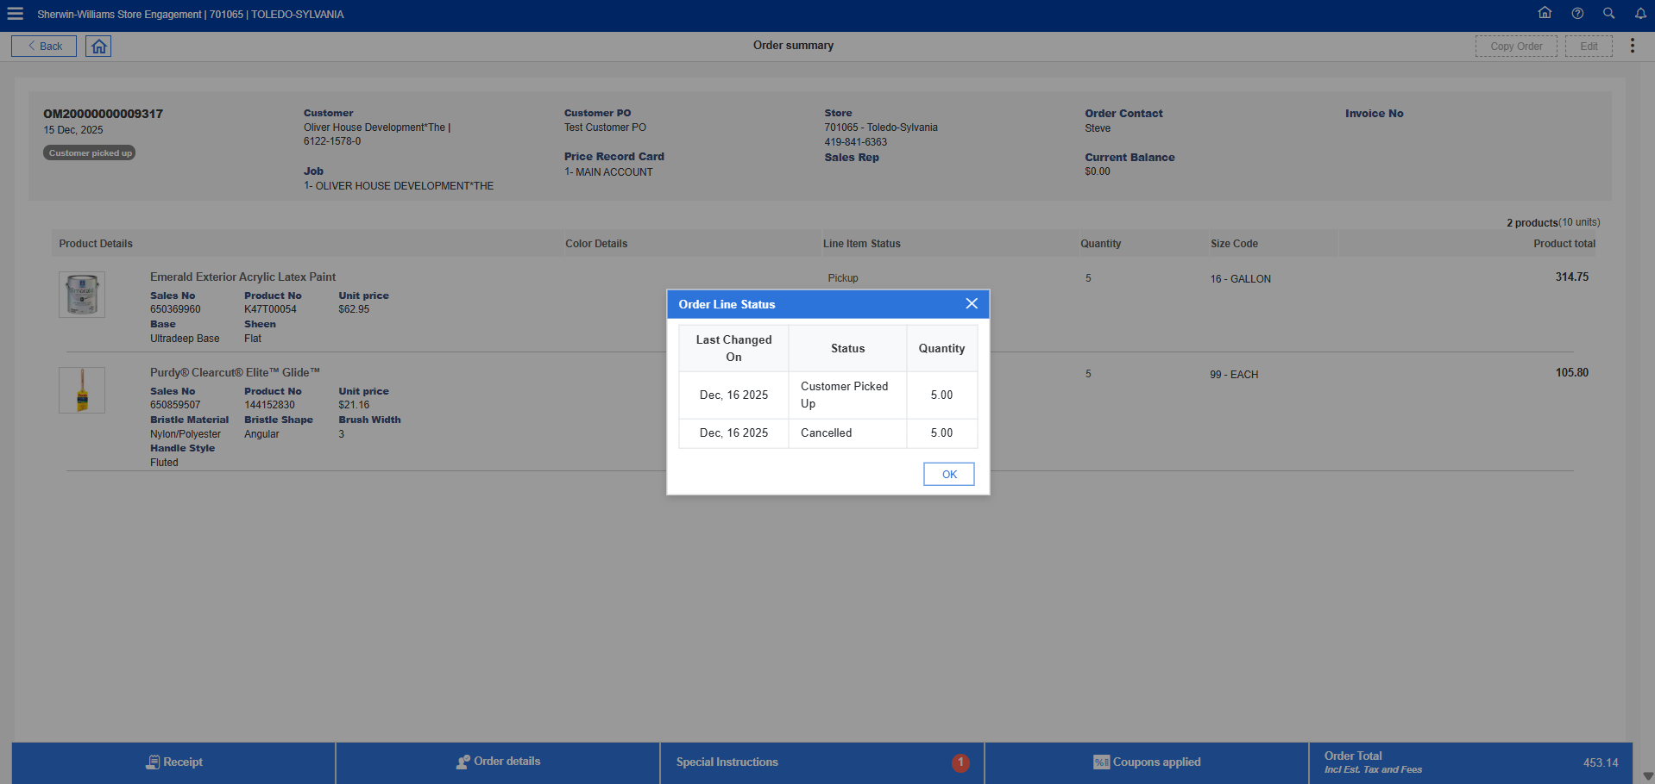

**Release XML**

Order No: **OM20000000009341 (Non-Tinted Item with Coupon) – Pending Cancellation**

**Ready for Pickup**

**Pending Cancel**

**Full Cancellation**

Logged in Store: **701065** || Account No: **612212472** || Order No: **OM20000000009342 (Tinted Item) – Complete Delivery- PASS  
Tinting In Process**

**Customer Picked Up**

Logged in Store: **701065** || Account No: **650475528** || Order No: **OM20000000009345 (Tinted, Non-Tinted, AP item) – Full Cancel – PASS**

**Ready for Pick Up & Tinting in Process**

**Full Cancel**

Logged in Store: **701065** || Account No: **281310433** || Copy Order No: **OE0176375Q701133**

**Copy Order Screen**

Order No: **OM20000000009353**

**Ready for Pick Up**

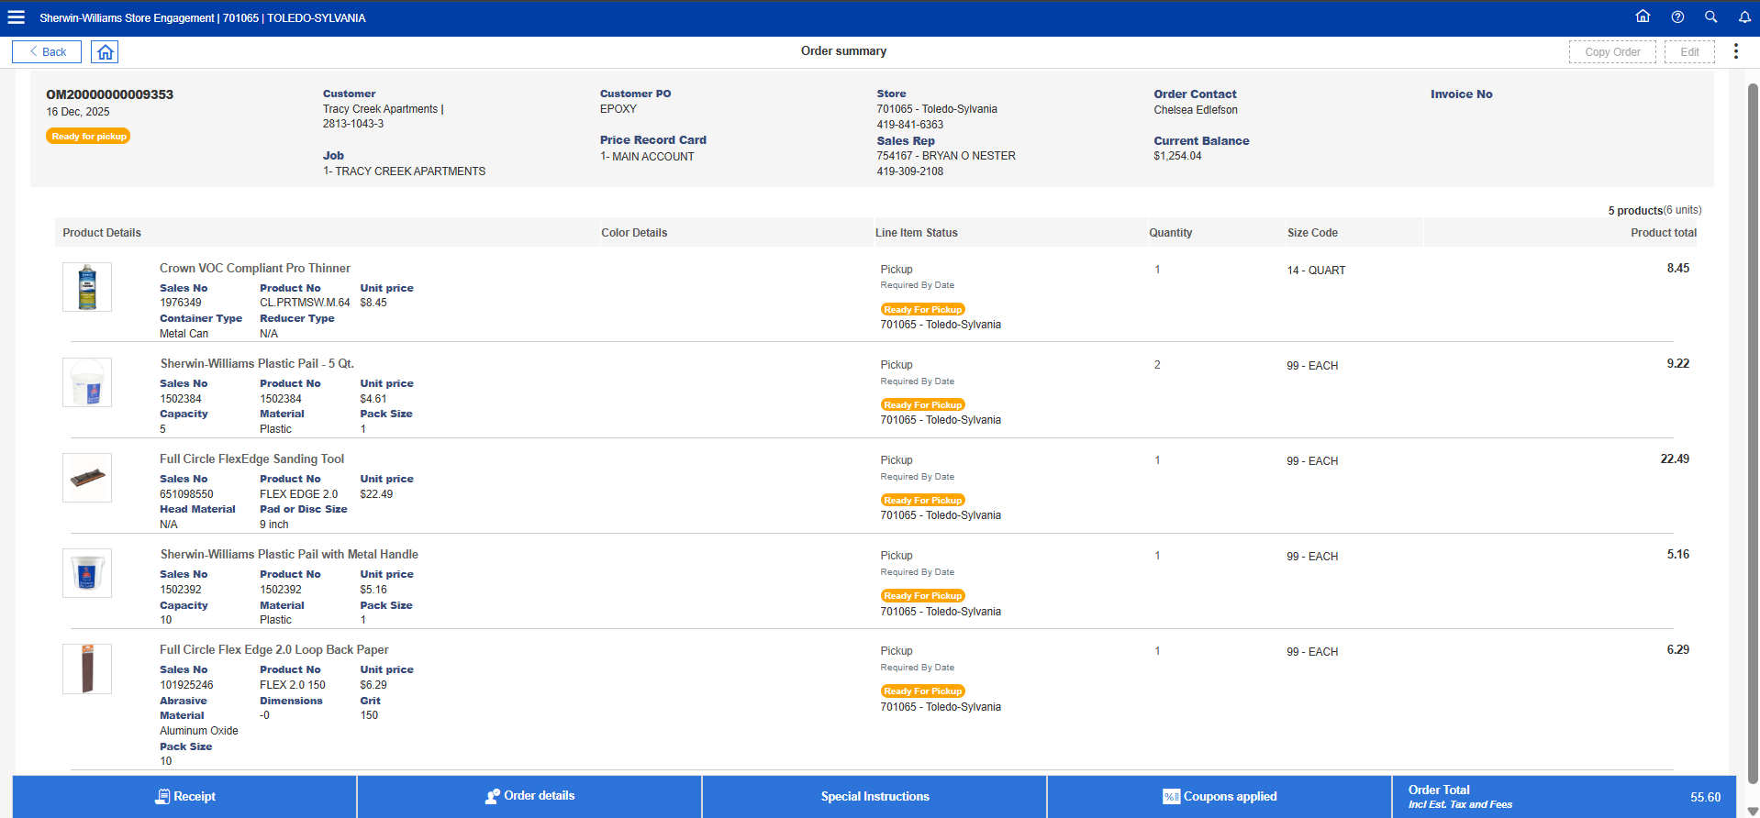

**Customer Picked Up**

**Release XML**

